**ADP to SkyPrep Migration Project**

Project Description:

The objective of this project is to migrate all Training & Certification data from the ADP platform to SkyPrep. The migration aims to ensure a seamless transition of data, maintaining data integrity and accessibility while minimizing downtime and disruptions to ongoing operations.

Project Scope:

Source System: ADP (Trainings and Certifications).

Target System: SkyPrep (Learning Management System).

Data to be Migrated:

* User Profiles.
* Training Records (Completed, In Progress, Assigned).
* Course Materials (Files, Descriptions, Metadata).
* Certification Records.
* Attendance and Performance Records.

Exclusions:

* Data not associated with active users.
* Erroneous records with no dates at all or blank training names.

Compliance:

Ensure compliance with data privacy and confidentiality regulations.

Source Documents (to be generated from ADP):

1. Voyago Deficiency_Recertification Report.xlsx
2. Policies_ Certifications_ Vaccines_ Licences Report.xlsm

**A. Voyago Deficiency_Recertification Report**

Steps to generate the report from ADP –

* Log into ADP
* Select Reports & Analytics
* Select all Custom Reports
* In the search bar type “def” and press the magnifying glass.

You should see the following report:

“Voyago Deficiency/Recertification Report”



* Press the blue circle with 3 dots and select Run.

Once the file is open, apply the following parameters:

You may need to adjust the Maximum # of records to 200,000 or more to ensure you pull ALL the records. Then press Run.



After pressing Run, you will be switched over to the Reports page where you can see your report running.



When the report is completed,

* You will see ‘completed’ under the status column and you will see a record count.

**\*IMPORTANT\*** check the record count.

* If your report parameter was set to 40,000 and the record count of the completed report is 40,000, chances are you do not have all the records.
* Re-Run the report with an increased “Maximum # of records”.

Sample Screenshot of the Report –

**B. Policies_Certifications_Vaccines_Licences Report**

Steps to generate the report from ADP –

* Log into ADP
* Select Reports & Analytics
* Select all Custom Reports
* In the search bar type “polic” and press the magnifying glass.

You should see the following report:

“Policies, Certifications, Vaccines, Licences”



* Press the blue circle with 3 dots and select Run.

Once the file is open, apply the following parameters:

You may need to adjust the Maximum # of records to 200,000 or more to ensure you pull ALL the records. Then press Run.



After pressing Run, you will be switched over to the Reports page where you can see your report running.



When the report is completed,

* You will see ‘completed’ under the status column and you will see a record count.

**\*IMPORTANT\*** check the record count.

* If your report parameter was set to 40,000 and the record count of the completed report is 40,000, chances are you do not have all the records.
* Re-Run the report with an increased “Maximum # of records”.

Sample Screenshot of the Report –



**Download the Reports:**

Click on the **Bold Name** of the report.

Another window will open and you will see a pop up showing your file is downloaded.  
This will download to your “Downloads” folder on your PC







**Open the ADP “Voyago Deficiency/Recertification Report” File:**  
**\*First and Foremost\*** Make a copy of the file you downloaded and perform your actions “use/manipulate/edit” on the copy.

* Open the copy of the file.
* Add Filters by pressing Alt then A then T. (not at the same time)
* Or go to Data then select Filters.
* Then select Sort and sort the data and press OK.



**Filter the Departments in the File:**

* Select the Drop-Down arrow in the “Home Department Code” column.
* Uncheck all the departments you want to keep.
* Go down the list and uncheck the departments you want to keep.
* A screenshot of a computer

  Description automatically generatedThen press OK.
* Highlight all the records.
* Right click and select Delete Row.
* Clear the filter.
* The remaining records are displayed.
* From here you can do what you need with the data.
* (PTS) NEMT Divisions 6,7,12,18,19,20,22,23,24,39, 41,66,72,

**Details of the ADP “Voyago Deficiency/Recertification Report” Report:**

Start date is the date the person was hired.

Acquired date is the date they started the training course.

Recertification date is the date the course will expire and will need to redo the training.

* If I see 01/01/2050 indicates a course that does not need to be recertified, is a one-off training course (policies, sign-offs)

If Course Name Description is blank - blank upload on ADPs part, disregard.

If Course Name Description is duplicated for a specific user, go by the oldest date for start, current date for Recertification and Acquired dates.

If Course Name Description and start date filled but no Recertification or Acquired dates - training not completed/uploaded to ADP.

If start date and Recertification and or Acquired dates are identical to Start date - training not completed/uploaded to ADP.

* I would remove the other dates in Recertification and Acquired Dates to clean the data



**Open the ADP “Policies, Certifications, Vaccines, Licenses” File:**  
**\*First and Foremost\*** Make a copy of the file you downloaded and perform your actions “use/manipulate/edit” on the copy.

* Open the copy of the file.
* Add Filters by pressing Alt then A then T. (not at the same time)
* Or go to Data then select Filters.
* Then select Sort and sort the data and press OK.

**Filter the Departments in the File:**

* Select the Drop-Down arrow in the “Home Department Code” column.
* Uncheck all the departments you want to keep.
* Go down the list and uncheck the departments you want to keep.
* A screenshot of a computer

  Description automatically generatedThen press OK.
* Highlight all the records.
* Right click and select Delete Row.
* Clear the filter.
* The remaining records are displayed.
* From here you can do what you need with the data.
* (PTS) NEMT Divisions 6,7,12,18,19,20,22,23,24,39, 41,66,72,

**Details of the ADP “Policies, Certifications, Vaccines, Licenses” Report:**

License/Certification Description is the descriptive name of the Pol/Cert/Vacc/Lic.

* If this field is blank, this was an erroneous record that was uploaded. Disregard.

License/Certification ID

* will only have a single record for each employee containing the License #.
* Expiration Date should have the Drivers License Expiration Date. No other record should have this.
* Drivers License Province should have the Drivers License province. No other record should have this.
* Drivers License Class should have the type of license. (G, GX, AZ, etc.) No other record should have this.

Hire Date is the date the person was hired.

Effective Date

* is the date the training was received and entered as completed.
* If this is blank and the Effective Date matches the Hire Date, this means the completed training was not received and will show as deficient from the hire date.

Expiration Date

* Generally, these courses are a “complete one time only” and do not require an Expiration Date.
  + Exceptions:
    - TBD Schools
    - Accessible Customer Service Policy Sign
    - Accessible Customer Service Policy Sign
    - Driver/Monitor Responsibilities: expires every year.
    - Confidentiality Policy Sign-off
    - STSYR Confidentiality Agreement
    - If this date matches the Hire Date and there is no Effective Date, this means the completed training was not received and will show as deficient from the hire date.
* If I see 01/01/2050 or a “Blank” this indicates a course that does not need to be recertified (see exceptions above)
* The example below is an employee that was hired in Jan 2020, was assigned training on June 2023, presumably after a return from leave. We see the employee returned from leave in August 2024 and thus the training was never received and is therefore deficient.
* 

Rehire Date is the date the employee was rehired.

Leave of Absence Return Date is the most recent date the employee returned from a leave.

Position ID is the unique ADP ID for the employee.

If Course Name Description is blank - blank upload on ADPs part, disregard.

If Course Name Description is duplicated, go by the oldest date for start, latest date for Recertification and Acquired dates.

If Course Name Description and start date filled but no Recertification or Acquired dates - training not completed/uploaded to ADP.

If Course Name Description and start date filled and Recertification and or Acquired dates are identical to Start date - training not completed/uploaded to ADP.

* I would remove the other dates in Recertification and Acquired Dates to clean the data



**SkyPrep Reports:**

**User Course Report**

* This report is used to compare what is currently in SkyPrep to what you see in ADP (the report above). This is an easier to work with report.
* Log into SkyPrep – you can also use your ADP login by clicking the ADP button.
* A screenshot of a computer

  Description automatically generatedA red and blue sign with white text

  Description automatically generatedSelect Admin Mode
* Choose Reporting and Reporting Wizard
* In the Reporting Wizard select:
  + Course, All Courses, Summary of User Progress
  + Then press Generate Report

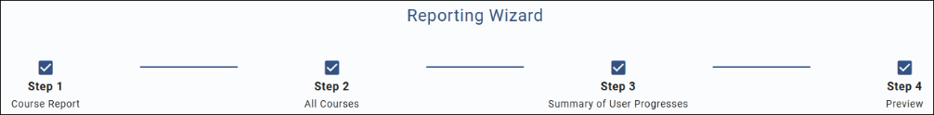

**User Management Report**

* This report is used for BULK updating and uploading to SkyPrep.
* A red rectangular sign with white text

  Description automatically generatedLog into SkyPrep – you can also use your ADP login by clicking the ADP button.
* A red and blue sign with white text

  Description automatically generatedSelect Admin Mode
* Choose Users & Groups and Users
* Click Bulk User Management
* If you just click “CSV Bulk Update Template”.
  + You will get a list of users without any course information.
  + This is good if you just want to Bulk update user information.
* If you check the “Include Courses” box, then click “CSV Bulk Update Template”
  + You get the list of Users along with all the courses and information (200+ columns)
  + This is used when BULK updating data in SkyPrep
* ***!!** NEVER edit the ‘skyprep_internal_id’ field **!!***

**Details of the ADP Report:**

Anything in Skyprep and NOT in ADP – do not worry about  
Anything in ADP WILL be in SkyPrep. Highlight anything different and let Chris Know.

**SkyPrep**

Reporting Wizard Step 1 Course Report

All Courses

Summary of User Progress  
Add 2 columns

Work Phone

Log in Status

Apply Changes and generate report

Active employees – current working employees

Disabled employees – do not work here - disregard

Inactive Employees - employees are on leave  
Every employee should have an employee number under workphone.

2LA Executives

NEMT are all MGV employee number (work phone)

OCE are also NEMT

If ADP has older date, discard, if ADP has newer date, update Skyprep.

In ADP Recertification Date of 01-01-2050. This is a single completion course and requires no recertification. Basically a one and done.

Expiration Date and Deadline Date is Recertification Date and should be the same.

Under workPhone is the PositionID from ADP

Course Progress Status -   
 Never pull a record from ADP and change that record to Archived or Failed in SkyPrep.  
 should never change from Passed to In-Progress or Non-Started  
  
Users

Bulk user management

Update (prefilled)

Uncheck “Include Courses”

Click CSV Bulk Update Template to download the file.

Update the data in this file ***!!** NEVER edit the ‘skyprep_internal_id’ field **!!***

Then Upload the file. In the same area select “Choose File” button. Select your file (name does not matter).

Press “Update Users” to upload.

You will see “Status Pending” then you will see the number of processed rows.

Add

Save

Go to skyprep

Choose file

Workphone is the the Employee ID

User had 2 Employee ID’s

There will likely be employees that have 2 work_phone id’s (this is the same as the positionID from ADP). They will all have one that is 4JH and one that is MGW. This is because in ADP we had to "hire" them in multiple companies for various reasons.

If you could just please make sure that their 4JH employee number is the one in Skyprep, and the dates are all updated to the most recent appropriate dates.that would be great.

Set up meeting with Cody Beselaere – To contact for details on training

**The Migration Utility**

(built using python for code logic and tkinter for windows GUI)

The different sections in the Utility are as follows:

* Clean Report section

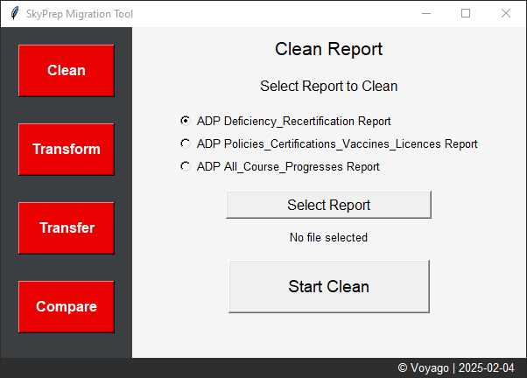

This section of the script is responsible for cleaning data from an Excel file before further processing. It applies specific cleaning rules depending on the report type and saves the cleaned data into a new file.

**Handling Different Report Types**

Each report type has different cleaning rules:

**Case 1: Deficiency_Recertification**

* Loads the Excel file and extracts only required columns.
* Filters rows based on conditions:
  + If Start Date exists but Recertification Date & Acquired Date are missing, keep it as is.
  + If Start Date and Acquired Date exist but Recertification Date is missing, remove Acquired Date.
  + If Recertification Date is greater than Start Date, set Acquired Date = Start Date.
  + If Recertification Date is equal to or earlier than Start Date, remove Acquired Date & Recertification Date.
* Saves the cleaned data into a new Excel file.

**Case 2: Policies_Certifications_Vaccines_Licences**

* Maps different column names (renaming fields like License/Certification Description → Course Name Description).
* Processes missing values:
  + If Start Date is missing but Recertification Date exists, set Start Date = Hire Date.
  + If both are missing, only keep Hire Date.
  + If Recertification Date = Hire Date, remove both.
* Sets a default Recertification Date (2050-01-01) if missing.
* Saves the cleaned data into a new Excel file.

**Case 3: All_Course_Progresses**

1. Removes duplicate entries based on a unique combination of Email and Course Name.
2. Sorts the data based on Start Date, Completion Date and Expiration Date.
3. Keeps only the latest records for each “Email | Course Name” combination.
4. Saves the cleaned data into a new Excel file.

* Transform Report section

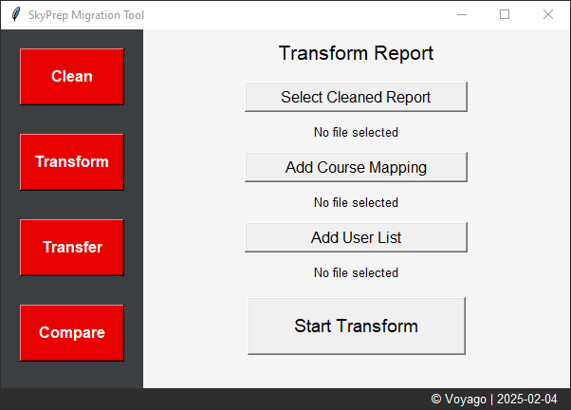

This section is responsible for transforming data from a given Excel file by mapping fields, modifying structures and preparing the transformed report. It also categorizes certain data into separate sheets for better organization.

File Selection

Allows the user to browse and select:

* Main Excel file
* Course Mapping file
* SkyPrep user list file

Creates a New Workbook for Transformed Data

Creates three sheets:

* **Transformed Data** → Stores the final transformed data.
* **Not Found Records** → Stores records where login status is "Not found".
* **Discarded Data** → Stores records where the course is marked as "Discard".

Handles Special Cases

* If a course is "Discard", moves it to the "Discarded Data" sheet.
* If course mapping is missing, marks it as "Course Mapping Not Found".
* If a user's login is "Not found", adds the record to Not Found Records.
* If "Course Progress Status" is "not-started", removes the start date.

The key features of this section are as follows:

1. *Automated Data Transformation* – Reads, processes, and structures data.
2. *Categorizes Data* – Moves discarded and missing records to separate sheets.
3. *Handles Missing Data* – Detects missing headers and user details.
4. *Dynamic Mapping* – Uses dictionaries for flexible column mapping.
5. *Progress Bar* – Provides real-time feedback on progress.
6. *Error Handling* – Prevents crashes by handling missing files and bad data.

* Transfer Report section

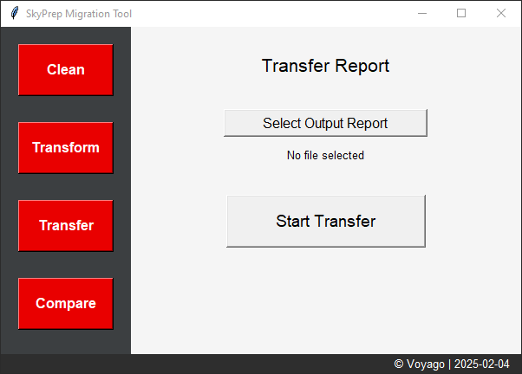

This section processes an Excel file, organizes the data into the SkyPrep Bulk User Update CSV format, and saves the result as a new Excel file.

The key features of this section are as follows:

* 1. Dynamically creates column names based on the number of courses  
     (max_courses default is 84).
  2. The output columns include basic user information like skyprep_internal_id, first_name, last_name, email_or_username and work_phone
  3. For each course (1 to max_courses), it generates the following columns:
     + course {i}
     + course {i} status
     + course {i} date started
     + course {i} date finished
     + course {i} access date
     + course {i} deadline date
     + course {i} expiration date

where {i} is the course number.

It ensures that each user’s courses are correctly mapped into the appropriate columns.

This step groups data by "SkyPrep ID", meaning data is processed per user.

* Compare Reports section

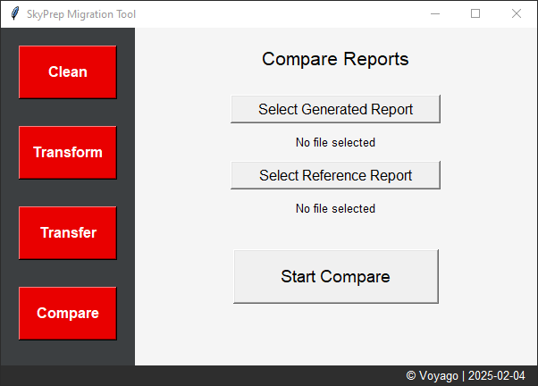

This section is responsible for comparing two Excel files:

Compare File – This contains the initial data from ADP.

Reference File – This contains the latest updated data from SkyPrep.

It checks if there are differences between the files and updates the Compare file accordingly.

Working logic for this section:

For each row in the Compare file:

* Extracts the SkyPrep ID, Last Name, First Name.
* Searches for a matching row in the Reference file.

Checks each course for differences:

* The script checks 84 courses (course 1 to course 84).
* Defines columns dynamically (e.g., course {i}, course {i} status, etc.).
* Checks if the columns exist in both files.
* Extracts the values for course status, start date, finish date and expiration date.

Logic for Updating Compare File:

- If the course is "passed" in both files, it compares:

date started

date finished

expiration date

- Updates the Compare file only if the Reference file has a later date.

- If the course is "not-started" in Compare but "passed" in Reference:

* It copies the status and dates from Reference to Compare.
* If date started or date finished is missing, it fills the missing field.

Log the updates:

Creates a log file called update_log.txt to keep track of all the records updated in this section.

The output of this step is the final Bulk Update CSV that we need to upload in SkyPrep Bulk User Management screen.